**Grid Configuration**

* **Copy Folder GridConfiguration from Below Path**

**\\192.168.10.216\MahiShare\GridConfiguration** **🡪 open as Hyperlink**

* Install Java in Your Machine from Java folder.

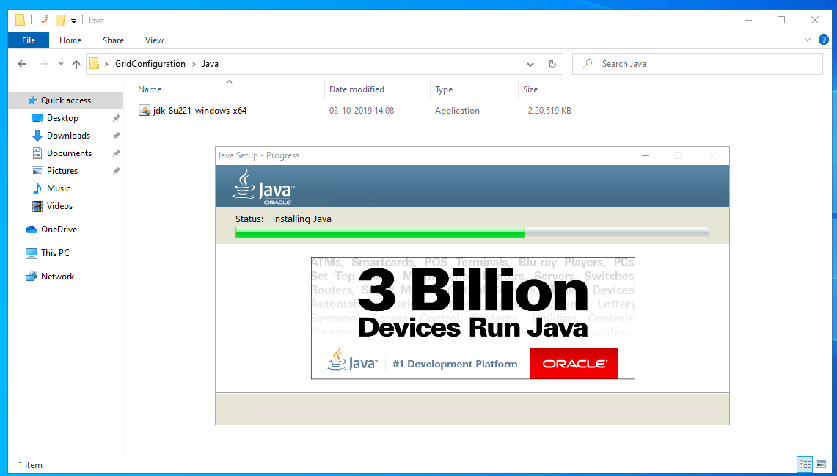

* Check Java Installed To your Machine By command.

Java -Version

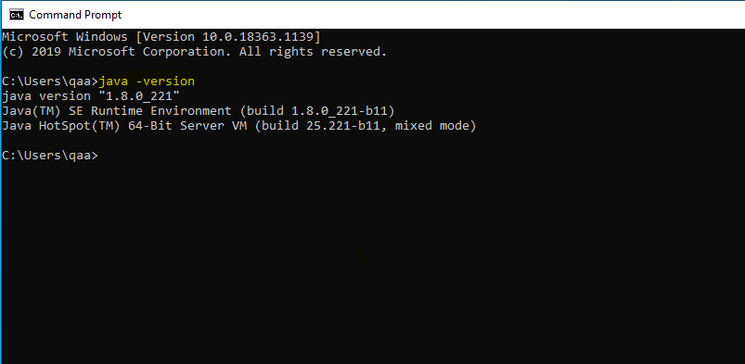

* Set Environment Variables for Java

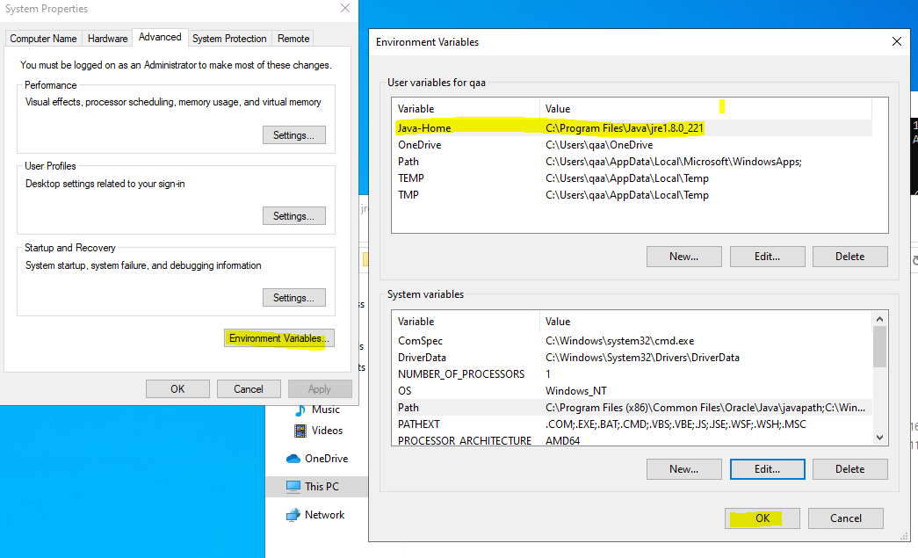

* Install Chrome and NotePad+ in Your VM/Machine

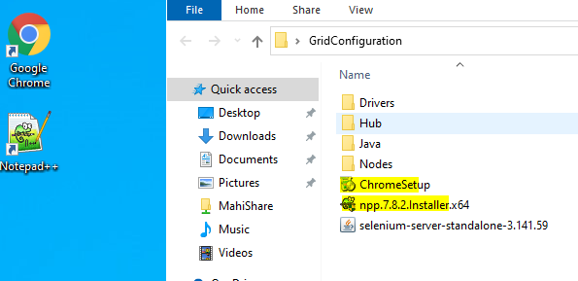

* To Start Hub go to Hub Folder And Edit HubStart.bat according to Your Machine Path and Double click.

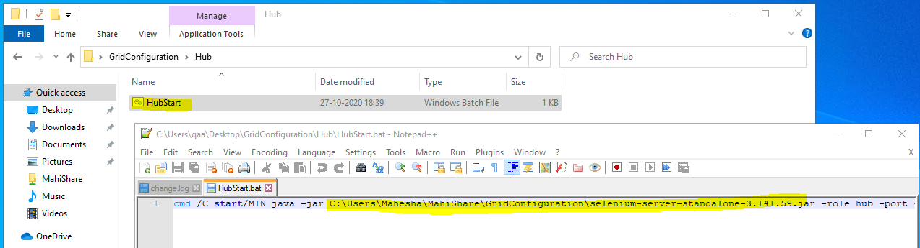

* To Start Hub go to Hub Folder And Edit HubStart.bat according to Your Machine Path and Double click.

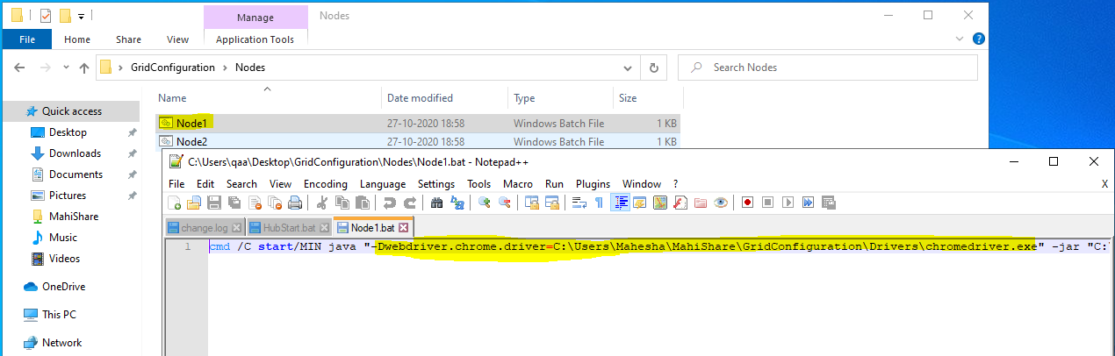

* You What to Configure Multiple nodes Configure as Node2 Node3 with Diff IP address and Diff Browser Drivers.

Thank You…